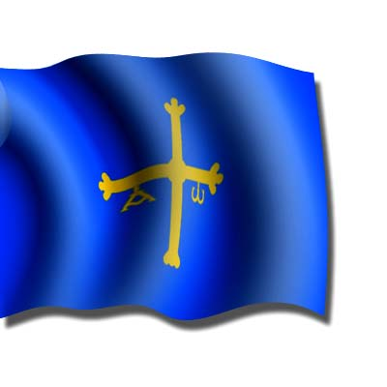

HELLO .WE ARE FROM SPAIN
My Autonomous Comunity is called The Principality of Asturias and it have one province.The capital is Oviedo.The municipality where I live is called Oviedo.In my comunity we speak one lenguage.

